**THE UNIVERSITY OF MALAWI**



**THE POLYTECHNIC**

**FACULTY OF APPLIED SCIENCES**

**DEPARTMENT OF COMPUTING AND INFORMATION TECHNOLOGY (CIT)**

**PROJECT TITLE:**

DEVELOPMENT OF ULTRAWERKS WEB BASED PLAT FORM FOR INTERACTIVE 3D VIRTUAL TOURS

**COORDINATOR:**

DR. A TAYLOR

**SUPERVISOR:**

MRS. E.KAFODYA

**BY:** GRACE FAITH CHIRWA (BIT/13/NE/003)

**04/September/2021**

**ABSTRACT**

ULTRAWERKs is an early startup brand that was initially found in 2016 as “OPUS STUDIOS”. It was later rebranded in January 2019 as “ULTRAWERKS”. The initial core of the business was to provide a platform for young architectural designers to expose their creative capacity to the professional forum as well as effectively engage with the customers. To achieve this, they heavily rely on virtual reality, specifically 3D virtual tours.

3D virtual tours are a sequence of panoramic images stitched together to create a virtual experience of any location. Essentially, they are 3D walkthroughs that enable the viewer to have an experience of an environment without physically being present. Interactive 3D virtual tours on the other hand allow users to explore the design without limiting control on what to see throughout the tour.

One challenge with the use of interactive 3D virtual tours in the architectural space is that it requires physical interaction between the designer and the client during the design phase. This is so since the interactive 3D virtual tours require specialized software which has high hardware requirements. The problem is that not all clients have the specialized computers which meet these hardware requirements. (challenges of sending interactive virtual tours remotely between different devices. Is it portable(possible) or cheap to do so)

3D virtual tour web platforms enable clients and the architects to interact remotely hence removing the inefficiencies associated with restricted physical meetings. ULTRAWERKs is in need of such technology to improve their business efficiency.

This document proposes an implementation of a web-based platform that will enable ULTRAWERKs manage the 3D virtual tours as well as engage their clients remotely.

List of Abbreviations and Acronyms

**RIBA** Royal Institute of British Architecture

**DFD** Data Flow Diagram

**3D** 3 Dimension

**VR** Virtual Reality

**HTML** Hypertext Markup Language

**CSS** Cascading Style Sheet

**MVC** Model View Control

**RAD** Rapid Application Development

**UDK** Unreal Development Kit

AGM Annual General Meetings

**Table of Contents**

**ABSTRACT…………………………………………………………………………………. I**

**LIST OF FIGURES………………………………………………………………………….II**

**TABLE OF CONTENTS…………………………………………………………………....III**

**1.0 INTRODUCTION ………….………………………………………………………….... 1**

1.1 Statement of research problems……………………………………………………2

* 1. **Proposed solution** …………………………………………………………………2
  2. **Research Questions ……………………………………………………………….2**
  3. **Research Objectives ………………………………………………………………3**
     1. Main objective………………………………………………………….3
     2. Specific Objective………………………………………………………3
  4. **Methodology review………………………………………………………………3**
  5. **Conclusion…………………………………………………………………………4**
  6. **Project Justification……………………………………………………………………….4**
  7. **Ethical Considerations……………………………………………………………4**

**2.0 LITERATURE REVIEW…………………………………………………………………5**

**2.1 Theoretical Framework ………………………………………………………….5**

2.2 **Definition Of Terms……………………………………………………………… 5**

**2.3 Software Used In Designing Interactive Virtual Tours……………………..…..6**

**2.4 Web based virtual tours………………………………………………………...…6**

**2.5 RAD system development approach methodology……………………………....7**

**2.3 Conceptual Framework…………………………………………………………...8**

**2.3.1 Work Specific To The Study…………………………………………………………….8**

**3. METHODOLOGY ………………………………………………………………………………..9**

**3.2 Methodology For Requirements Collection ……………………………………9**

3.2.1 Questionnaires………………………………………………………….. ..9

3.2.2 Interviews ………………………………………………………………..9

3.2.3 Observation……………………………………………………………….9

3.2.4 Review data acquisition…………………………………………….……..9

* 1. METHODOLOGY FOR REQUIREMENTS ANALYSIS ……………………10
  2. Method For Design Concepts & System Proposal…………………………….…...10

3.4.1 User interface

3.4.2 Systems module design

3.5 System Construction and Testing

3.5.1 System Construction…………………………………………………………………10

3.5.2Methodology For Testing …………………………………………………………..11

3.6 Development Technologies ………………………………………………………..11

3.7 Implementation Plan………………………………………………………………..11

**4.PLANNING OF ACTIVITIES AND SCHEDULE………………………………….…………..11**

**4.1 Activities………………………………………………………………………………………….12**

4.2 Budget……………………………………………………………………………………………..12

**REFERENCES**…………………………………………………………………………….....………..… 13

List of Figures

Figure 1 The iterative RAD development process...................................................................................8

Figure 2 ULTRAWERKs DFD Level-0 diagram......................................................................................9

Figure 3 context diagram……………………………………………...………………………………..9

Figure 4 Project Work Plan (Gantt Chart).............................................................................................12

Figure 5 Budget.....................................................................................................................................12

DEVELOPMENT OF ULTRAWERKS WEB BASED PLATFORM FOR INTERACTIVE 3D VIRTUAL TOURS

**CHAPTER 1**

1. **INTRODUCTION**

The 21st century is considered to be the century of new globalization. The entire world has been driven into the digital age where technology is highly depended on. The impact of the internet has been a catalyst for a major rise to new opportunities of trade which has led to speedy growths of economies. The introduction of digital technologies has led to changes in various sectors in the business industry through the breakthrough of “Virtual reality” a computer-based simulation technology capable of depicting real environments for users to experience live-like presence. The virtual world plays a crucial role in this. Technology has gone a step further to make virtual technology “real” by showcasing places just the way they are  ( Moturi, 2014).

The architectural space is one of the industries that has greatly advanced by the use of these technologies. ULTRAWERKs is a Malawian architectural company that has adopted many of the technologies in the architectural space. ULTRAWERKs is an early startup brand that was initially found in 2016 as “OPUS STUDIOS”. It was later rebranded in January 2019 as “ULTRAWERKS”. The initial core of the business was to provide a platform for young architectural designers to expose their creative capacity to the professional forum as well as effectively engage with the customers.

Architectural design ideas have been processed and represented in various ways throughout architectural history. Traditionally architectural designs used basic representational techniques such as drawing, painting, collage, photography, and modeling. According to Jie Yan, use of these techniques presented a number of challenges. One of the significant challenges being the difficulty in communicating these designs to clients due to lack in knowledge of the symbolism architects used in the designs (Yan, 2014). As such the use of Two-dimensional representation sparked great interest in architectural space for it enabled clients to understand the design without in-depth knowledge of the symbolism.  (Arpak, 2008) Modern times the interest has shifted towards 3-Dimensional representations which improved visualization capabilities of the two-dimensional representation. Furthermore, the architects have leveraged the technology by blending virtual reality and 3D models to create virtual tours.

3D virtual tours are a sequence of panoramic images stitched together to create a virtual experience of any location  ( Moturi, 2014). One major challenge with the use of 3D virtual tours in the architectural space, for new architectural businesses is that it requires physical interaction between the designer and the client. This is so since the virtual tours require specialized software which has high hardware requirements. This is where the challenge is rooted on, consequently the other problem is that not all clients have the specialized computers which meet these hardware requirements. The good news is that, it is expected that VR drift will eventually spread faster and in order to purchase basic VR content, consumers do not need to buy expensive hardware. They just have to add accessories that will change their smartphones into VR devices (Barnes, 2016).

As the noble profession that it is, architects follow a code of personal conduct. This conduct on Guide Note number two speaks on specifically how they can advertise that states that it is unethical for Architects or Quantity surveyor to publicize or advertise their work anyhow. There is an actual guide to how that can be done to qualify the mode of advertisement for each practitioner of their profession. It is because of this that most new architects in the industry’s only way is to market through known registered firm and when architects share each other’s portfolios or they are assembled during an Annual General Meetings.

Physical meetings introduce limitations to architectural processes in a number of ways. Firstly, they are costly in terms of travel expenses. For instance, ULTRAWERKs which is based in Lilongwe has to send Architects to Mulanje just to meet a client for collection of project requirements on a design concept or conduct a presentation on progress reports. Secondly Physical meetings require time synchronization. For instance, the architects and the clients should both slot in a plan to meet physically which is convenient to both parties. Thirdly, physical meetings hinder rapid communication between the two parties which is required in the design process. For instance, the two parties have to interact for the customer to give feedbacks.

**1.1 Statement of research problems**

The existing methods of client engagement in the process of architectural design stage are in adequate when it comes to supporting **rapid communication**, **cost minimization** and client **convenience.**

**Rapid communication,** architectural designing requires constant and active feedback between the client and the designer. The designer has to show the modifications to the design and the clients has to provide feedback on the work. With the requirement of physical meetings timely feedback is significantly impacted.

**Cost minimization,** the current requirement of conducting physical meetings requires travelling which in turn incur costs. The need to have constant communications entails more travelling, and consequently more cost.

**Convenience,** physical meetings mean both the designer and the client need to have synchronized time. Reviews and feedback don’t need to be delayed because one party is not available. The current methods do not provide opportunity for the design review to have convenient time.

**1.2 Proposed solution**

Due to the highlighted problems, the development of a web-based platform for interactive 3D virtual tour will enable ULTRAWERKs remotely engage its clients. Specifically, the clients will be able to access the virtual tours providing the review convenience. Additionally, the platform will provide a rapid communication channel to support timely feedback and cost minimization. Companies applying the methods and tools of modern marketing communications are able to cooperate rapidly with clients (Lysik & Lopacinski, 2009).

* 1. **Research Questions:**
* What are the prospects for implementing virtual tour in marketing Architectural designs?
* What are the potential challenges for adopting virtual tours?
* What are the current methods used to present the designs and what are their shortfalls?
* What are the challenges that architects meet when showcasing their work?
* How do the clients and the architects interact when working on a project and how can this be improved through the use of interactive models?
* How will an interactive platform improve the timely feedback collection, cost minimization and enhance convinience?
* How will an online platform improve on customer’s involvement in the design phase?
* How can the online platform improve the company’s marketing strategy?
* How far will it go, eradicate the marketing strategies they use now for the web-based unity game engine virtual tour because of the site?

**1.4 Research Objectives**

1.4.1 Main objective

The main objective is to develop a 3D virtual tour web-based platform for ULTRAWERKs to effectively engage its clients in the architectural design process consequently improve in its business efficiency.

1.4.2 Specific Objective

* To analyze non-web-based methods of delivering 3D virtual tours to understand their challenges.
* To analyze web-based methods of delivering 3D virtual tours to employ the techniques.
* To develop web-based 3D virtual tour platform to enable ULTRAWERKs to upload its virtual tours.
* To develop a web-based 3D virtual tour platform to enable ULTRAWERKs conveniently access the uploaded virtual tours without necessitating possession of high-performance computer devices.
* To integrate a communication channel on the platform to enable rapid communication flow between designers and the clients.

**1.5 Methodology review**

**Royal Institute of British Architects** whose goal is to support British Architects and introduce people to the world of architects. RIBA Architecture website is a platform for architects’ community that also offers many services. Among these many services will discuss on a few that are relevant with our study. The platform connects the architects all around the world that have joined this community to clients that reach out to them through this platform. There moto states that the greater they are the louder their voice. Another service is a section within this platform that incorporates virtual reality known as FAAM. Freestyle Architecture Adventures in Mass Media where freestyle offers online exhibitions from the renaissance to postmodernism through the use of virtual reality. Basically, exploring historical events through virtual reality in the comfort of your home or space. Freestyle also offers talks, tours and workshop on its platform using their platform. All this is possible using virtual worlds and virtual tours incorporating Mass media to give the user an experience in a virtually interactive atmosphere (RIBA Architecture, n.d.). www.RIBA Architecture.com

**Virtual tour tool for enhancing destination marketing** by Ernest Nyagari Moturi was built to help tourist in decision making on a particular destination they would like to visit in Kenya. Moturi deviced a virtual tour interface by using soft prototyping methodology when developing and guiding the research. The study recommends further research on the use of virtual tours on fighting crime through crime scene investigation, learning through creation of tutorials and reducing the size of virtual tours. ( Moturi, 2014)

**Virtual reality in marketing communication** -the impact on the message, technology and offer perception –empirical study was conducted by Filip Grudzewski, Marcin Awdziej, Grzegorz Mazurek,

Katarzyna Piotrowska. They performed an empirical research which involved an experiment with 150 observations of participants to find out the relationship between virtual reality and marketing. The results obtained reveal that VR technology positively and significantly impacts the reception of the offer, the technology involved and the presentation itself. (Grudzewski, Awdziej, Mazurek, & Piotrowska, 2018)

**Virtual worlds and the 3D web -time for convergence**

Hussein Bakri, Colin Allison, Alan Millerand Iain Oliver conducted a study to find out if Virtual Worlds and the 3D Web–time for convergence. The aim was to contribute to the knowledge of terms such as Web and Multi-user Virtual Worlds(MUVW), technologies and projects, to demonstrate their similarities, their value in education and discuss the possibility of merging. This was a cultural inheritance case study of Unity 3D support on the deployment of virtual worlds in web browsers using two different approaches. However, with the no evidence in Chrome and Mozilla towards plugin-less browsers Unity is dropping UWP in favor of WebGL which may result in better optimized output. In summary there are many signs of convergence but it is still not possible to state categorically that direct support for immersive environments in the standard web will increase user demand which in turn will spur further and faster innovation in web-based immersive education. (Bakri, Allison, Miller, & Oliver, 2016)

**Conclusions**

Most of the reviewed projects are focusing on web based virtual tour though others are not as interactive as others and other software’s used are not as efficiently displaying their interactive tours because they are not web compatible. This project will use the 3D unity game engine and the web-based platform to provide an ability for both parties to interact remotely through the platform through the internet services and the web browsers. Unity has also multimedia capability and web compatibility and the technologies used in some of the reviewed projects work well with unity. Unity has a shorter designing period and is cost effective since its free version produce satisfying result and many more agreeable alternatives for this project. The process will also include participants that are willing clients of ULTRAWERK to analyze if the use of virtual tours has an effect on the process of designing, and those clients will be our sample in the project.

**1.6 Project Justification**

The more a design is interactive the more the client respond better and engages more, making the design more like tailor made design which meets the client’s satisfaction. Unlike still presentations, clients quickly give feedback instantly which improves the design process. This gives room for the designer to understand the clients’ preferences and producing a perfect design that a client desire. This was proven by Hajduk who already conducted a similar project. He states that, companies using the procedures and tools of modern marketing communications cooperate quickly with consumers (Hajduk, 2017)

The development of this web-based 3D virtual tour platform will enable ULTRAWERKs improve business efficiency in a number of areas by singly eradicating physical meetings. First the company will enjoy cost optimization since there will no longer be need to travel. Secondly the company will improve its customer relations since the platform will enable them conveniently engage clients by providing a rapid communication channel as well as allow the clients to access the 3D virtual tour and give timely feedback at their convenience.

**CHAPTER 2**

1. **LITERATURE REVIEW**

**2.1 Theoretical Framework**

This section will briefly explain some terms, a few examples of web based virtual tours. This will help to get acquainted within idea within this project.

**Architecture** is an art and a science of designing as well as building structure and surroundings with artistic features to accomplish some specific purpose that give sense of excitement to the viewer (Janetius, 2020).to shade more light, this project is based on an architectural company mainly on managing the virtual tours they create for their clients for visualization as a marketing strategy.

**Architectural designs** are concepts that focus on components or elements of a structure. This is where an architect, who is in charge of the design works with space and elements in order to come up with a coherent and functional structure(Cummins architecture & designs, 2021)**.** Architectural design has commonly a lot of stages but According to Cummins architecture and designs they can be split down into four which are as follows:

* First is the schematic design where the architect gathers the requirement information of the client’s requirements on the project from which they create a sketch for clients to review.
* Secondly, the design development follows, this where the schematic designs are developed into approved design concepts.
* Thirdly are the construction documents, that are given to the contractors to use for building.
* Fourthly is the bidding stage where a constructor is selected.
* Construction stage is the actual building of the infrastructure.

So, our project is falling under the first two stages mainly the second stage.

**Technology and architectural designs**

VR technology is a developing innovation that affects client’s perception of the products to which they have been exposed to in a stimulating manner. Virtual Reality has been studied beforehand and found to have a optimistic influence on product perceptions and purchase intentions because of brand experience (Van, Brengman, & Willems, 2017a). Architects during design process want to engage their clients effectively throughout. Visualization has made this possible to bridge the gap between the designer and the client by using graphics to demonstrate a concept. Architectural designs can be presented virtually with the help of 3D format and numerous technologies.

**Visualization** in general is a way of picturing a concept in your mind, with a technical perspective it means to display a behavior of any complex state graphically and understandable for the human eye. Technically it has been made possible with the help of computers to display information in a graphical manner. (S.Gallagher, 2012)With advances in technology, visualization is possible in 3D form and has also included virtual reality for more interactivity with the content. For instance, in architecture fields structural components such as computer aided designs are used to illustrate design models and virtual reality visualization make the static 3D models more interactive.

**Virtual reality (VR)**

Virtual reality is a form of computer-generated data visualization that is highly interactive and a 3D environment that offers user an experience into a simulated world as a participant. It is used to display a simulated environment with objects and scenes as though its real. VR in real estate is commonly referred to websites with virtual tours displaying 360-degree pictures. (Onyesolu & Eze, 2011).

**Virtual tour**

A simulation of an environment using a series of images or videos and different media such as sound or text to emulate a place and to create a presence. The degree to which the tour can immerse the user into the virtual world is distinguished into three. Non- immersive, partially immersive or fully immersive and this project will use partial immersive virtual tours because the necessary gear such as google or oculus HTC glasses or motion sensors are not yet available.

**Interactivity**

The measure to which the user can engage with the environment, weather exploring completely independent or guided experience. There are multiple interactive elements such as hotspots for teleportation, texts, videos, sounds. Most interior walkthroughs only allow users to see the 3d environment (i.e., a guided fixed navigation), but does not allow users to freely explore and navigate the virtual setting themselves (Meiling, 2015)

**Software used in designing interactive virtual tours**

There are different software’s that can create virtual tours others are open source while others are not.The software’s defer depending on what kind of virtual tours it is designing. Virtual tours can be made from either 360-degree pictures stitched together or videos even architectural models. Others are interactive virtual tours that allow users to navigate interactively in the tour through without restrictions while others are not interactive and limit user the control of what they see. Virtual tours that are more interactive are those designed in a game engine because of its multimedia compatibility. Game engines are also known to create fully immersive virtual tours.

**Game Engines**

Developing a virtual 3D environment by using game engine is a strategy to incorporate various multimedia data into one platform. The difference between using an average 3D design software and a gaming software as a 3D design software is the ability for interactive virtual environment. Users are allowed to experience a dynamic and interactive virtual interior environment by using 3D gaming software as the design software. (Meiling, 2015)

Using game software technology in the 3D design field has overall shorter virtual construction process (Indraprastha & Shinozaki, 2009).

There are many game engines on the market that are readily available, research by Smith and Trenholme (2008) shows that first-person shooter (FPS)game engines generally have more robust features for modifications. While there certainly many more engines to choose from that can be looked at, our consideration is on model interactivity, low cost and still render in a short time. In that case this project we will be using Unity’s game engine ability to use content that is playable in a web browser. Unity can run smoothly on a fairly basic configured computer and does not involve more dynamic computer to be able to run smoothly. (Schroeder, 2011)

**Web based virtual tours**

These are virtual tours embedded on a web platform and can be accessed randomly on the monitor of any graphical user interface compatible network device.

* **First Texas homes**

It’s a website with a gallery of interactive 3D virtual tours incorporating all necessary details to help in decision marking for a house purchase. It includes floor plans, interior and exterior designs which can also be used to inspire customers that would like to offer a new conceptual design to the builders. The virtual tours were designed by matter port.

* **Matter port** is a service provider through the use of its website that it charges after first trial. It one of the top websites know for creating virtual tours because of its ability to depict a realistic environment.
* **My360**

It is more of a website that includes features that is focused on users creating the virtual tours. First trial is of no costs and allows fully customized tour, charges are made from the second and continuous attempt. The challenge is that the services are expensive.

**Virtual World Framework (VWF**)

is a platform that connect virtual creations and 3D objects and content through web browsers. It is an open-source platform that allows anyone to build interactive 3D applications on the web. It also spans and interfaces with existing client-server virtual worlds like OpenSim making it possible for these settings to be delivered in a lightweight manner through web browsers. VWF uses WebSocket’s and WebGL to deploy in the web browser the challenge with these technologies is that they are limited in media support.

**RAD system development approach methodology**

The system development approach that will be used in this project is the rapid application development (RAD). This is a methodology that aims at getting some portion of system developed quickly and in users’ hands, to develop a system quickly even if the requirements are not fully known. This methodology is considered to be unique because it has special techniques and tools which are known as Computer aided system engineering (CASE) tools.

CASE tools are software packages used to integrate requirement documentation, design as well as specifications for a system. (Dennis, Wixom, & Roth, 2009) It is also helpful in coding an information system. Joint Application Development (JAD)sessions using visual programming languages and code generators from the analysis and design specification. Prototyping, CASE, and JAD are key tools that support rapid application development (Valacich, George, & Hoffer, 2012).

RAD has a number of approaches within it such as iterative, system prototype and throw away prototype. Iterative development this involves dividing the project into series of versions developed sequentially with the fundamental requirements in the first version and is a mini waterfall process. System prototyping performs the analysis, design, and implementation phases concurrently in order to quickly develop a simplified version of the proposed system and give it to the users for evaluation and feedback. Throw away prototyping includes the development of prototypes, but uses the prototypes primarily to explore design alternatives rather than as the actual new system (as in system prototyping).

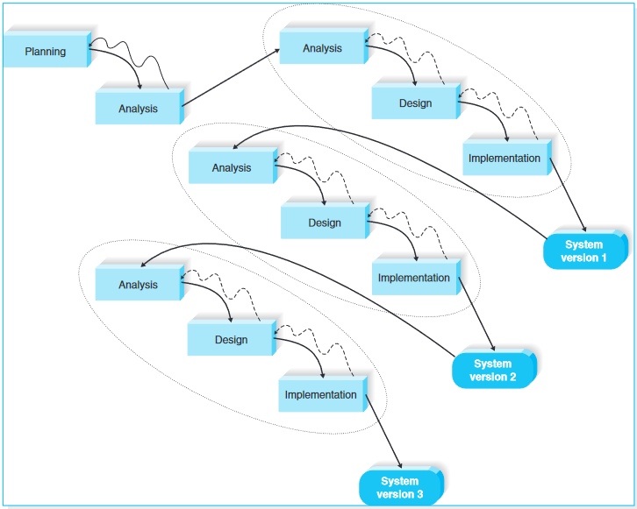

Figure 1 The iterative RAD development process from essence in system analysis and design

2.3 CONCEPTUAL FRAMEWORK

This section is to appreciate related literature to this project.

2.3.1WORK SPECIFIC TO THE STUDY

**Brest’Coz**

Brest’Coz is web-based application built in the 18th century, a site that a user can interactively visiting the harbor of Brest, France. Initially was developed for the navy to orient them on a particular task. As the tour begins a virtual guide in form of an avatar is available to give direction based on the goal of the user.AI has been incorporated in the system the, the agent uses the knowledge acquired from physical or social activities taking place on the platform. Semantic modelling was used to create the virtual environment and the activities of the agent for conceptualization of the dialogue. The benefit of this approach is that the dialogue rules are autonomous from the contents of the application and semantics are clear. These principles were used to develop Brest’Coz, an interactive virtual tour for the learning shipbuilding techniques that France used in the early 18th century. (Laboratory of Computer Science for Complex Systems, France2Dialonics, Lannion, France, 2011)

**Unreal game development**

One of the main aims of architectural visualization is to ease the communication between architects and clients. Architects work with multiple two-dimensional technical drawing information about the building that is stored in multiple types of data sheets. Clients usually have no deeper knowledge about the subject matter. They have to learn skills to interpret the architectural designs. No matter how much the client learns, his communication will not be on the same level as the architect’s. Lexical communication is too inaccurate to communicate clearly spatial relations, and traditional visual communication with technical drawings requires mental imagery generation on the client side. However, mental imagery generation of the information receiver should be kept at its minimum for the purpose of leaving more capacity for the more important spatial reasoning process. Additionally, communication can fail because client and architect are creating different mental imagery. Using three-dimensional visualization compared to technical drawings minimizes mental imagery generation on the

client side, while reducing the information load on the working memory. Additionally, abstract data that is included in the technical drawings can be integrated into the visualization, reducing the analyzing process connected to the abstracted information. This reduces miscommunication about spatial relations.

(Amresh & Okita, 2010)

**Real-time Interactive Architectural Visualization using Unreal Engine 3.5**

This study was on the investigation of the Unreal Development Kit (UDK) and the potentials it offers for architectural visualization. To create a cost and time competent solution, a workflow development Maya plugin was invented and used to change architectural data into UDK assets. To use UDK for architectural visualization, the UDK was extended with a modular framework that offers these features: transferable environments, time of day visualization, interior lighting, basic architectural sharers, and an interface for user interaction. The system was used to build a demonstration prototype for visualizing a minimalistic house. The prototype was evaluated in a qualitative user study. The results show that users react positively to the visualization and that is has potential for marketing uses. There were challenges in terms of the plug in not indicating an error if the user would forget to indicate to save the document. There was such a possibility because of the lengthened process during the laying out objects which well affected the and also the system has no ability to export the positions from Maya to UDK. Future projects can build upon the framework to investigate other UDK features, for example, dual-device interactions. (Burger, 2013)

**CHAPTER 3**

* 1. **METHODOLOGY**

**3.1.1System Development Methodology**

This section discusses system design, methods, that was used for this project. As of the methodology, the system adopted the iterative RAD approach in system development, with iterative development approach this is to have the core functionalities prioritized in the first version of the system available as a prototype. Other discovered functionalities were added on as we enquire more requirements

from the clients and incorporated into the platform which is one of the advantages of iterative development approach.

**3.1.2 Outline of The System**

The system will mainly be used by three types of users which are the administrators, architects, client’s customers and mere users. Administrators will have functionality for all the typical administrative duties such as management of user accounts and maintenance of the technical aspects of the system. As for the architects they will be able to upload the architectural designs and interact with their clients. Similarly, the clients will be able to access the 3D virtual tour designs as well as interact with the architect. The system will provide a communication channel in form of messages, chats so that architects and clients can communicate back and forth.

3.1.2.1Population

3 interviews

3.1.2.2target population

ultrawerk

3.1.2.3sample size

How many interviews

**3.1.3 Context diagram and Level 0 DFD**

**3.1.3.1 context diagram**

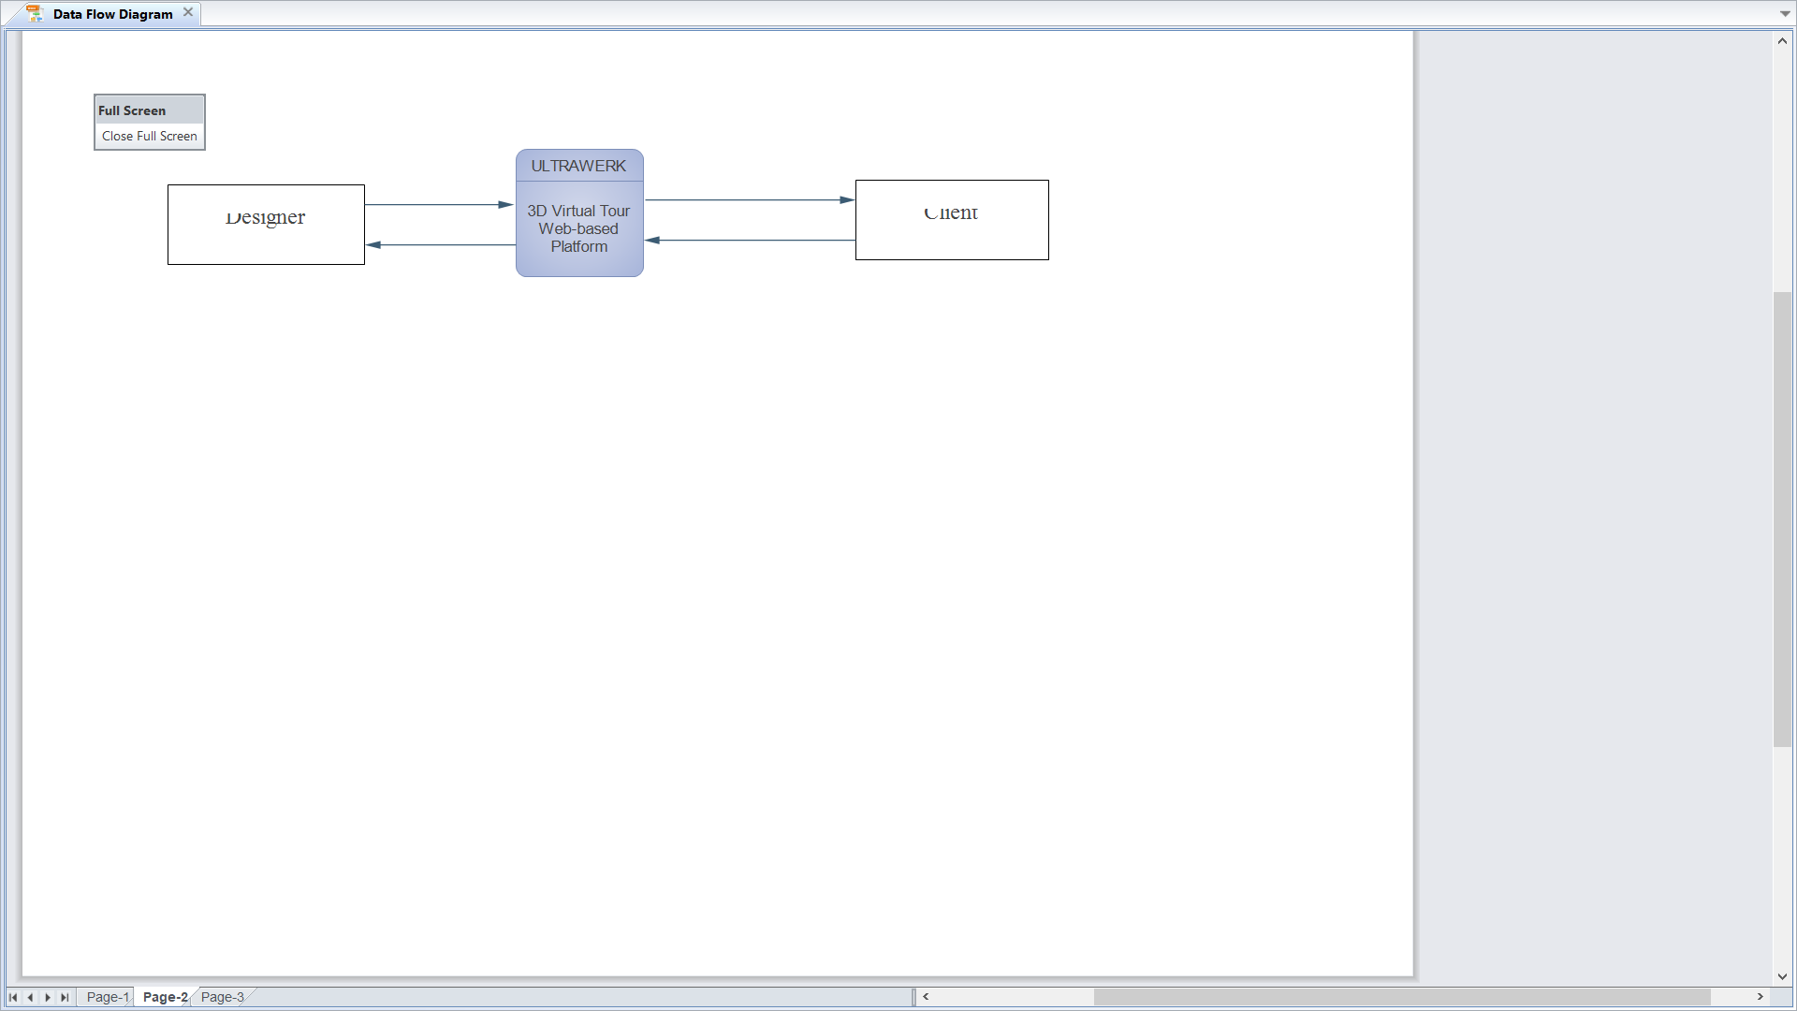

Figure 2 Context diagram

**3.1.3.2 Data flow diagrams (DFD’s)**

DFD were used to illustrate processes or activities that will happen in the system and the data that is accepted between different users. This data analysis method can also be referred to as **Process Modelling.**

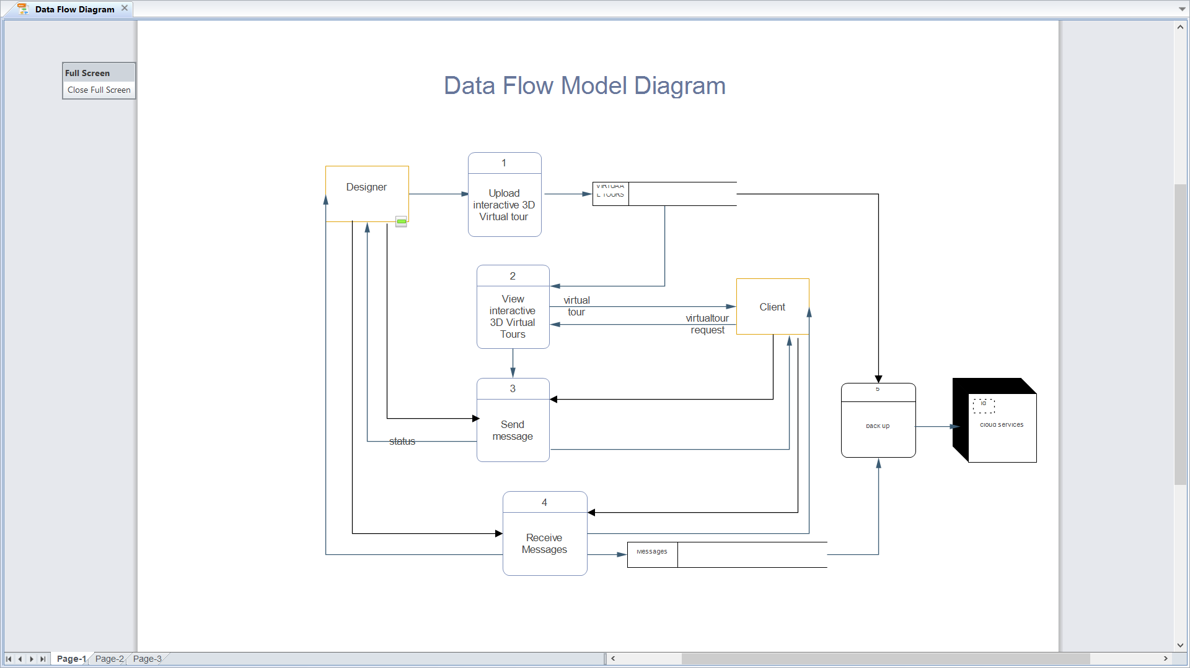

*Figure 3 DFD Level 0 diagram*

**3.2 Methodology For Requirements Collection**

The development of the interactive 3D virtual tours platform used the following data acquisition techniques:

3.2.1 Questionnaires

A combination of both open and closed ended were used as a reflective questionnaire to collect input on the platform to experimental customers of my client. This was to evaluate the ease of use and insight on more functionalities to put into considerations

3.2.2 Interviews

Since questionnaires are limited in nature, interviews were preferred than questionnaires in the preliminary study. During the development phases, interviews were performed with the client, MR M.Mang’anya to provide more information about the problem and what the system should really do and preliminary data. Another interview was conducted with another party MR Sam Chidonthe who happens to be the chief architect at Malawi Housing. As someone who is in the industry more than my client but is also using similar methods as my client, this interview was to identify the possible and identical problems to recognize and verify if my clients’ problems are common in the architectural space. This selection was made using purposive sampling technique with open ended questions in order to get a more descriptive record on how architects perform their duties, processes and operation.

3.2.3 Observation

Since we used iterative method of system development approach, we used observation. The first version was given to the users to see how they are interacting with the prototype to discover other features that they need to add value.

3.2.4 Review data acquisition

There are numerous web-based platforms being employed world-wide, we will use the review data acquisition methods to observe similarities within the projects.

* 1. **Methodology for requirements analysis**

Analysis is based on the data generation process (DGP) which affects how data will be classified and also affects which tool or method will be used to best be analyze that particular kind of data.

* + 1. Data analysis

Most of the data collected was qualitative data resulting to a qualitative data analysis…(thematic and content analysis?)

According to the interviews that were conducted and the process description on how my client goes through when conducting a project gave more insight on the project flow.

It starts when the customer contacts the architect and express interest on the project they have and requiring of the architects’ services, usually through a Phone call or an email. Then they schedule on a face-to-face meeting for more details, if possible, otherwise can operate over the phone same first phone call.

The first meeting is a debrief for the early development and enquiring possible constraints that the architect must know beforehand.

Things enquired are like,

* is there a piece of land or property for adjustments that need to be made or not?
* Where is the site if any?
* What is the size of the land?
* What is the terrain of the land e.g. rocky, plains, steep, hilly, lake shore and the like?
* Orientation on what is the plan or purpose; the intended use of the project?
* What are the other services that the customer wants from you apart from the design?

This exercise gives the architect a scope and an idea of what his doing, how big it’s going to be. After that then a vision board creation and presentation are done in order to provide possible inspirational layouts, images and things that could be replicated.by doing so the architect gets the sense of the idea as well as the customers sense of style.

Having collected all this information, the debrief is recorded and sent to the customer for confirmation or corrections. Following from this a quotation is made for that particular project and this is where negotiations and agreements are made. Plans on payments and what have you weather in installments or once off payment.

Next is the initial concept, a basic floor plan, layouts, concept images, rendered plans, animations if project is big are used for the concept presentation through visualization.

This is sent to get feedback from customer if this is what they would want for their project and possible changes. There is a constraint here if a client is changing a concept and there is need to consider, if the changes are two times the value of the previous quotation it attracts extra fee and the quotation changes.

If the customers agree with the concept the next stage is drawing the construction drawings for the engineers, which the final stage in design whose output is the construction document.

Types of documents throughout the whole process

* + Project brief
  + Quotation
  + Proof of payment
  + Concept drawing, a basic floor plan, layouts, concept images, rendered plans and animation
  + Construction drawing as submission documents
    - 1. Database design

A database is shared collection of logically related data, and a description of this data, designed to meet the information needs of an organization. (Connolly & Begg, 2005). Relational databases have advantages over file-based systems which include data integrity, security, synchronized access, and uses a small storage space. This platform will use MySQL database, a free DBMS (open source) because it is a relational, easy to use and has powerful tools.

* + - 1. Entity relationship diagram **(**ERD)

ERD were used to recommend on how data is generated through the system as well as the information relationship displayed on the ERD’s. A three-step process as presented by Alan Dennis was used to create the ERD’s (Dennis, Wixom, & Roth, 2009). The process is presented in Table 3.0 below

|  |  |
| --- | --- |
| **Step 1** | Identify the system entities e.g. **user** |
| **Step 2** | Identify attributes to the entities e.g. **username** as an attribute for the entity, **user**. |
| **Step 3** | Identify and establish relationships among the entities e.g. One client can request for, a number of services. |

***Table 3.1 Three step process to creating an ERD***

3.3.2 SYSTEM ARCHITECTURE   
The system will use the client server architecture which is the preferred architecture for web-based platforms. The system will consist of a smoke detector device which will be connected to the central server through the GSM network. The central server will host an SMS server application, a database server, fire incident management system and a GIS map for each fire detecting device. The central server will be connected to   
Google map servers through the internet to access their JavaScript API for maps. The following   
diagram shows the overview of the system architecture. 18   
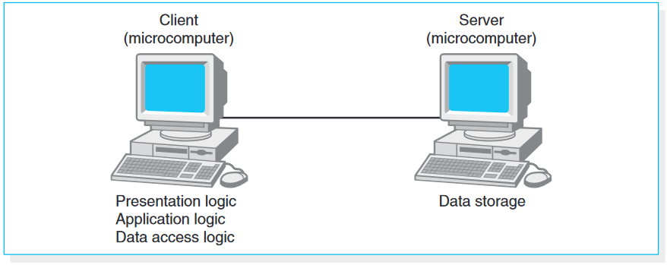

Figure 2 System architecture

* + 1. Use cases diagram

Use case diagrams were used to study and recognize the kind of users of the system and what activities a user can perform in the system: tabular format were used which are known as the system HIGH level Use Cases. The choice was based on the reports to be processed. These use cases provided more detail on the processes the system has to perform to meet the system requirements, and the data the system will need to capture and store.

Generally, each requirement will have its own use case below is the templet of the use case this project will use:

|  |  |  |  |  |  |
| --- | --- | --- | --- | --- | --- |
| Use case name: | | ID: | | Importance level: | |
| Primary actor: | | | | | |
| Short description: | | | | | |
| Triggering Event: | | | | | |
| Trigger type: | | | | | |
| Major Inputs  Description | Source | | **Major Outputs**  Description | | Destination |
|  |  | |  | |  |
|  |  | |  | |  |
|  |  | |  | |  |
|  |  | |  | |  |
| Major Steps Performed | | | **Information for Steps** | | |

***Table 3.2 Use case template***

3.4 METHOD FOR DESIGN CONCEPTS & SYSTEM PROPOSAL

3.4.1 User interface

User mockups screens will be developed using sketch using wireframe software, and will be validated by the client to see if the user interface is usable.

3.4.2 Systems module design

Program modules will be determined early on and overall module goals will be clearly specified and defined.

**3.5 System Construction and Testing**

3.5.1 System Construction

Using the RAD development approach, the project will be developed in versions where each version will accomplish its own set of requirements with the core function ready. What is more important at this stage are the module specifications. In this case have the platform ready and have a number of virtual tours ready and embedded to the platform.

3.5.2Methodology for Testing

The system will undergo several tests during each phase. Unit test will be carried out at programming level to ensure that the program module works correctly. After completion of each version, will conduct a system test to ensure that the various programs in that version are working correctly. An integrated test will be run after every version to ensure that the various modules are working together without error.

3.6 Development Technologies

After examination of existing suitable technologies for platforms like these we are going to use the Java and MYSQL for the back end and in the front end will use ReactJS, HTML and bootstrap. Java is a highly performant language that is used in enterprise level applications, specifically Java Spring boot MVC framework for building web-based java applications. As for the database the MYSQL database will be used based on the fact that much of the data this system will be dealing with is structured and MYSQL is very optimized and designed for such systems.

ReactJS is a user interface developed and maintained by Facebook and a community of open-source developers for building highly interactive interfaces. since this system is about interactivity this technology is very appropriate for this project. Bootstrap is a CSS styling library known as the world’s highly responsive front-end framework. Java Spring boot library is an MVC framework for building highly performant enterprise applications. It has an MVC (model view controller) architecture.

3.7 Implementation Plan

Finished versions of the system will be deployed on a temporary server and made accessible to the client, in this case ULTRAWERKs for them to pilot the system and provide feedback to be feed into the next versions of the software.

**CHAPTER 4: ANALYSIS**

The analysis chapter should include the following headings and sub-headings:

**4.1 Introduction**

Problem statement is on current methods of client’s engagement during the design process of the project are inadequate when it comes to rapid communication, convenience and cost minimization. To sum up the research questions were to find out if the proposed web based platform for interactive 3D virtual tours is feasible and can help meet the needs of my client.

This section documents the analysis of the system to be implemented and converses the process of defining system requirements. It consists of the following: Section 4.2 through section 4.7 discusses system design and analysis for Incident management system. Section 4.8 covers system analysis and design for the system.

Requirement analysis will be discussed in several sections, through the discussion of data-flow diagrams, data dictionary, entity-relationship diagrams, and process description.

**4.2 User Requirements/Target users**

As earlier stated in chapter 3 under the outline of the system the Architect, administrators, clients and mere user are the systems target users.

* generate general view of the system

**4.3 System Requirements**

The requirements of a system as explained in the previous chapter were collected through interviews with the client during preliminary data collection. A requirement is simply a statement of what the system must do or what characteristics it needs to have. (Denis, et al., 2009). Definition of these requirements further distinguishes which of the requirement are functional and nonfunctional requirements for the developing system.

4.3.1 Functional requirements

Functional requirements relate to the process the system has to perform or the information that it needs to contain (Denis, et al., 2009). These requirements may include the services, tasks and functions the system is required or expected to perform. The functional requirements have been characterized according to the system users.

* The client should register for an account,
* The Administrator should be able to create an account
* The Architect/admin should be able to log into default account
* Client should be able to login.
* The client should create a profile
* The client should be able to tour though uploaded virtual tours
* The administrator/Architect of the to Upload virtual tours
* The administrator/Architect of the to Delete virtual tours
* The user should receive notifications through email.
* The client should interact with virtual tours.
* The architect should Schedule for a meeting.
* The ability of the client to approve or deny requests.
* The users should view feedback in the chatroom.

4.3.2 Nonfunctional requirements

Nonfunctional requirements refer to behavioral properties that the system must have, such as performance and usability. Nonfunctional requirements are classified into operational, Performance, security and cultural and political. (Denis, et al., 2009).

4.3.2.1. Operational nonfunctional requirements

These requirements describe the physical and technical environments in which the system will operate

The system will be a web based system works installed on a server

The system should be able to be accessed on any smart device through any web browser

4.3.2.2. Performance nonfunctional requirements

This is the speed, capacity and reliability of the system.

The system should be available and accessible at all times

The system will have a database:

The database should be scalable to handle more virtual tours and other data

Database should be accessed simultaneously and still

4.3.2.3. Security nonfunctional requirements

This talks about who has authorized access to the system under what circumstances.

The users have restricted access levels depending on the user’s functionalities.

The ability to track who logged into the system at a particular time for auditing purposes.

**4.4 System Data Requirements Analysis**

4.4.1 Data Sources

4.4.2 Requirements Data Determination/(analysis)

4.4….

4.4.***n*** Summary – <Context Diagram, Logical Data Structures >

**4.5 System Processes Analysis**

4.5.1 Intro

4.5.2 DFD/use case - Functional Modeling of the system- Data Flow Diagrams or use cases

USE CASES   
A use case is a formal way of representing how a business system interacts with its environment   
(Denis, et al., 2009). The use cases describe in more detail the key elements of the requirements   
definition. To be exact, the use cases explain the process by which the system will meet the   
functional requirements that were defined in the previous phase.

4.5.2.1 use case actors   
In simple terms, system actors are the users of the system. Depending on the Requirements   
Definition, the actors of the Ultrawerks Studios web based platform are:

4.2.2.1.1 ADMINISTRATOR   
The system administrator are responsible for managing the system. For instance, they will be able   
to initiate the process of registering system users and staff members.   
4.2.2.1.2 FIRE OFFICERS Fire officers will be responsible for proving the system with for processing and storage. The main   
data that the fire officers will input into the system are: - 1. Fire incidence details 2. Fire department income details 3. Hydrant inspection details 4. Fire vehicles details 5. Fire department staff member’s information 6. Staff members leave details

25   
  
4.2.2.2 USE CASE TABLES   
After analyzing the system’s functional requirements and identifying the system actors, Use Cases   
were defined. These Use Cases are presented starting from the next page in a tabular format.

|  |  |  |  |  |  |
| --- | --- | --- | --- | --- | --- |
| Use case name: Users register | | ID: 1 | | Importance level: High | |
| Primary actor: customer | | | | | |
| Short description: Use case to enable interested customers to register to be system users and have their own users account to access the system. The login credentials are provided to the user | | | | | |
| Triggering Event: Users requesting to have an account | | | | | |
| Trigger type: External | | | | | |
| Major Inputs  Description | Source | | **Major Outputs**  Description | | Destination |
| Registration details | Users and system administrators | | User details | | Customer details |
|  |  | |  | |  |
|  | | | | | |

|  |  |  |  |  |  |
| --- | --- | --- | --- | --- | --- |
| Use case name: Creating account | | ID: 2 | | Importance level: HIGH | |
| Primary actor: Admin | | | | | |
| Short description: To create the accounts of clients that have registered and contacted the architect for services | | | | | |
| Triggering Event: Admin creating accounts while adding new users | | | | | |
| Trigger type: External | | | | | |
| Major Inputs  Description | Source | | **Major Outputs**  Description | | Destination |
| Account credentials | admin | | Account created | | Account details |
|  |  | |  | |  |
|  |  | |  | |  |
| Major Steps Performed | | | **Information for Steps** | | |

|  |  |  |  |  |  |
| --- | --- | --- | --- | --- | --- |
| Use case name: Login | | ID: 2 | | Importance level: High | |
| Primary actor: Clients, Architect and System administrator | | | | | |
| Short description: Use case to provide the functionalities that are allow authorized users to access the system with | | | | | |
| Triggering Event: Users and system administrator requesting to access the system | | | | | |
| Trigger type: External | | | | | |
| Major Inputs  Description | Source | | **Major Outputs**  Description | | Destination |
| Authentic user details | User and system administrator | | Authentication request | | System users and system administrators directed to home pages if authentic |
| Registered system users details | System user data store | |  | |  |
| Registered system administrator details |  | |  | |  |

|  |  |  |  |  |  |
| --- | --- | --- | --- | --- | --- |
| Use case name: Project details | | ID: 3 | | Importance level: | |
| Primary actor: Customer | | | | | |
| Short description: Customer gives in project details as well possible physical constraints that are put into consideration when designing | | | | | |
| Triggering Event: Customer expressing interest and contacting the architect for services | | | | | |
| Trigger type: External | | | | | |
| Major Inputs  Description | Source | | **Major Outputs**  Description | | Destination |
| Design suggestions | Customer | | Signed confirmed debrief | | Project debrief |
| Debrief | Project brief file | | Rejected debrief | | Architects personal file |
| Confirmed debrief | Customer | |  | |  |
| Major Steps Performed  Customer fills in project details  Architect reviews and sends debrief to client  Customer confirms debrief | | | **Information for Steps** | | |

|  |  |  |  |  |  |
| --- | --- | --- | --- | --- | --- |
| Use case name: Quotation | | ID: | | Importance level: | |
| Primary actor: Architect | | | | | |
| Short description: Selection of services and total sum of service charges | | | | | |
| Triggering Event: | | | | | |
| Trigger type: | | | | | |
| Major Inputs  Description | Source | | **Major Outputs**  Description | | Destination |
| Release quotation | Service selection | |  | |  |
|  |  | |  | |  |
|  |  | |  | |  |

|  |  |  |  |  |  |
| --- | --- | --- | --- | --- | --- |
| Use case name: Process payment | | | ID: | Importance level: High | |
| Primary actor: Architect | | | | | |
| Short description: Use case on negotiations on the services charges, modes of payments and installments | | | | | |
| Triggering Event: Architect sends quotation on the services requested for the project | | | | | |
| Trigger type: Temporal | | | | | |
| Major Inputs  Description | Source | **Major Outputs**  Description | | | Destination |
| Selected services | Service file | Invoice | | |  |
| Quotation |  |  | | |  |
| Payment details | customer | Proof of payment | | |  |
|  |  |  | | |  |

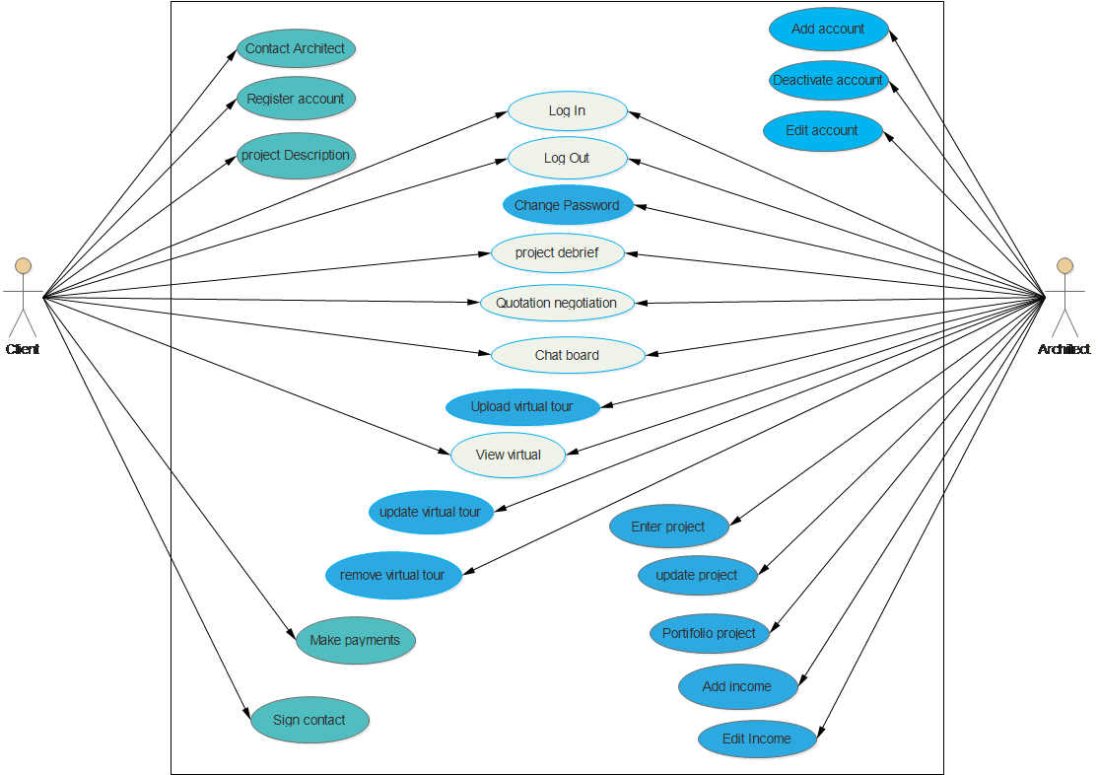

Figure Jacob Use case diagram

4.5.***n*** Summary

**4.6 < system proposal >**

• Alternative ways of solving the problem

• Proposed Solution with reasons

• Evaluation of tools- Pros and Cons

• Choice of Final Tool(s) with justification

• Detailed description of the system

**CHAPTER 5: DESIGN**

The Design section documents the design decisions that have been taken. The structure of the system and its components has to be established.

The various system design issues that have to be addressed are:

• Software Design Approach

• Performance

• Robustness

• Interactively

• Flexibility

• Re-usability and portability

• Security

The design should also consist of the following:

• Architecture Design – Interaction between components and/or modules

• Interface Design

• System Modeling – UML diagrams

• Database Design – ERD diagram

• Story Board

Design chapter should include the following sub sections:

**5.1 Introduction**

Architecture Design – Interaction between components and/or modules

The requirements and architecture can be used to develop the hardware and software specifications that define hardware and other software like the database systems are needed to support the system being developed. The objective of architecture design is to determine what parts of the application  
software will be assigned to what hardware

Client -server Architecture



**5.2 System Design**

Standalone, web-based …etc.

SW Design

* identified required modules/functionalities <as from above>
* modularity/decompositions

programs’ specifications (and algorithms)

**5.3 Database design**

*Erd, …etc*

The database for Ultrawerks Studios’ web based platform was designed by following the  
procedures as follows:

1. Identify entity types

2. Identify relationship types

3. Identify and associate attributes with entity or relation types

4. Determine candidate, primary and alternate keys

5. Develop the physical design

5.3.1 IDENTIFY THE ENTITIES The following entities were identified in the incident management system 1. U

DB design

* *the physical database design based on the data model* <specification includes entities, attribute types + lengths of, key types, default values , …etc
* normalization/ERD <thru traditional structured approach or mapped from class model in UP/OOM approach – *diag. essential*>
* stored procedures and triggers

**5.4 Interface Design**

Interface design is the process of defining how the system will interact with external  
entities such us the customers, suppliers, and other systems. (Dennis, Wixom, & Roth, 2009).

*User interface design plan*

User Interface Design

* interface design {<diag.> , <combine UI design with use case descriptions>
* *use case modeling based on the functionality and target user groups, - granularity/modularity issues??*
* screen shots

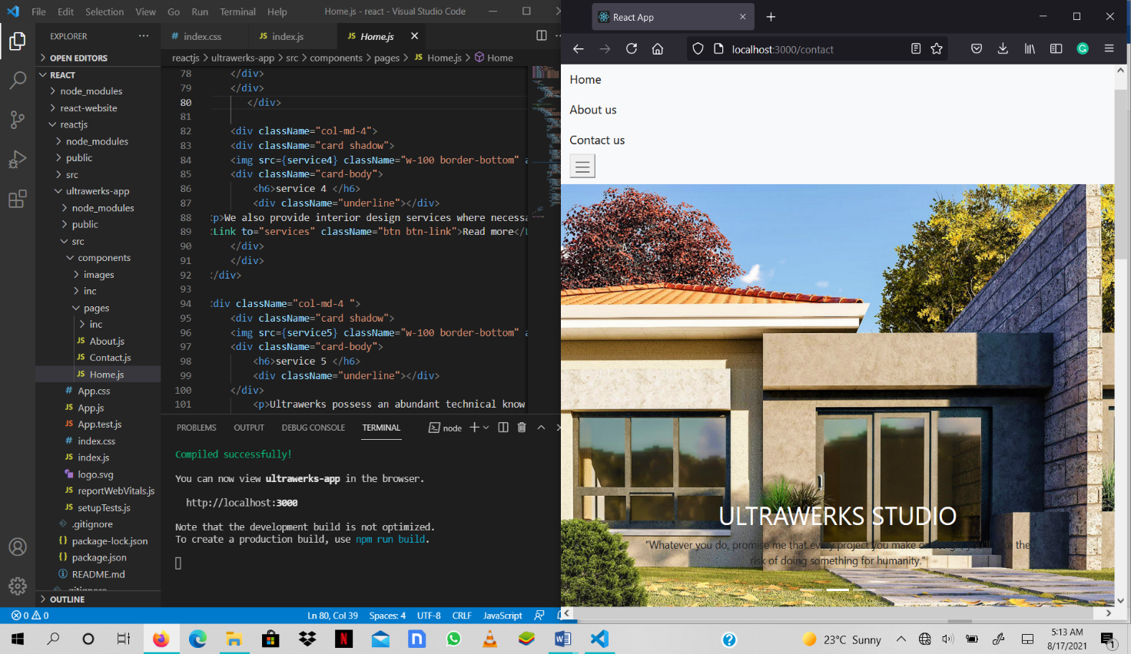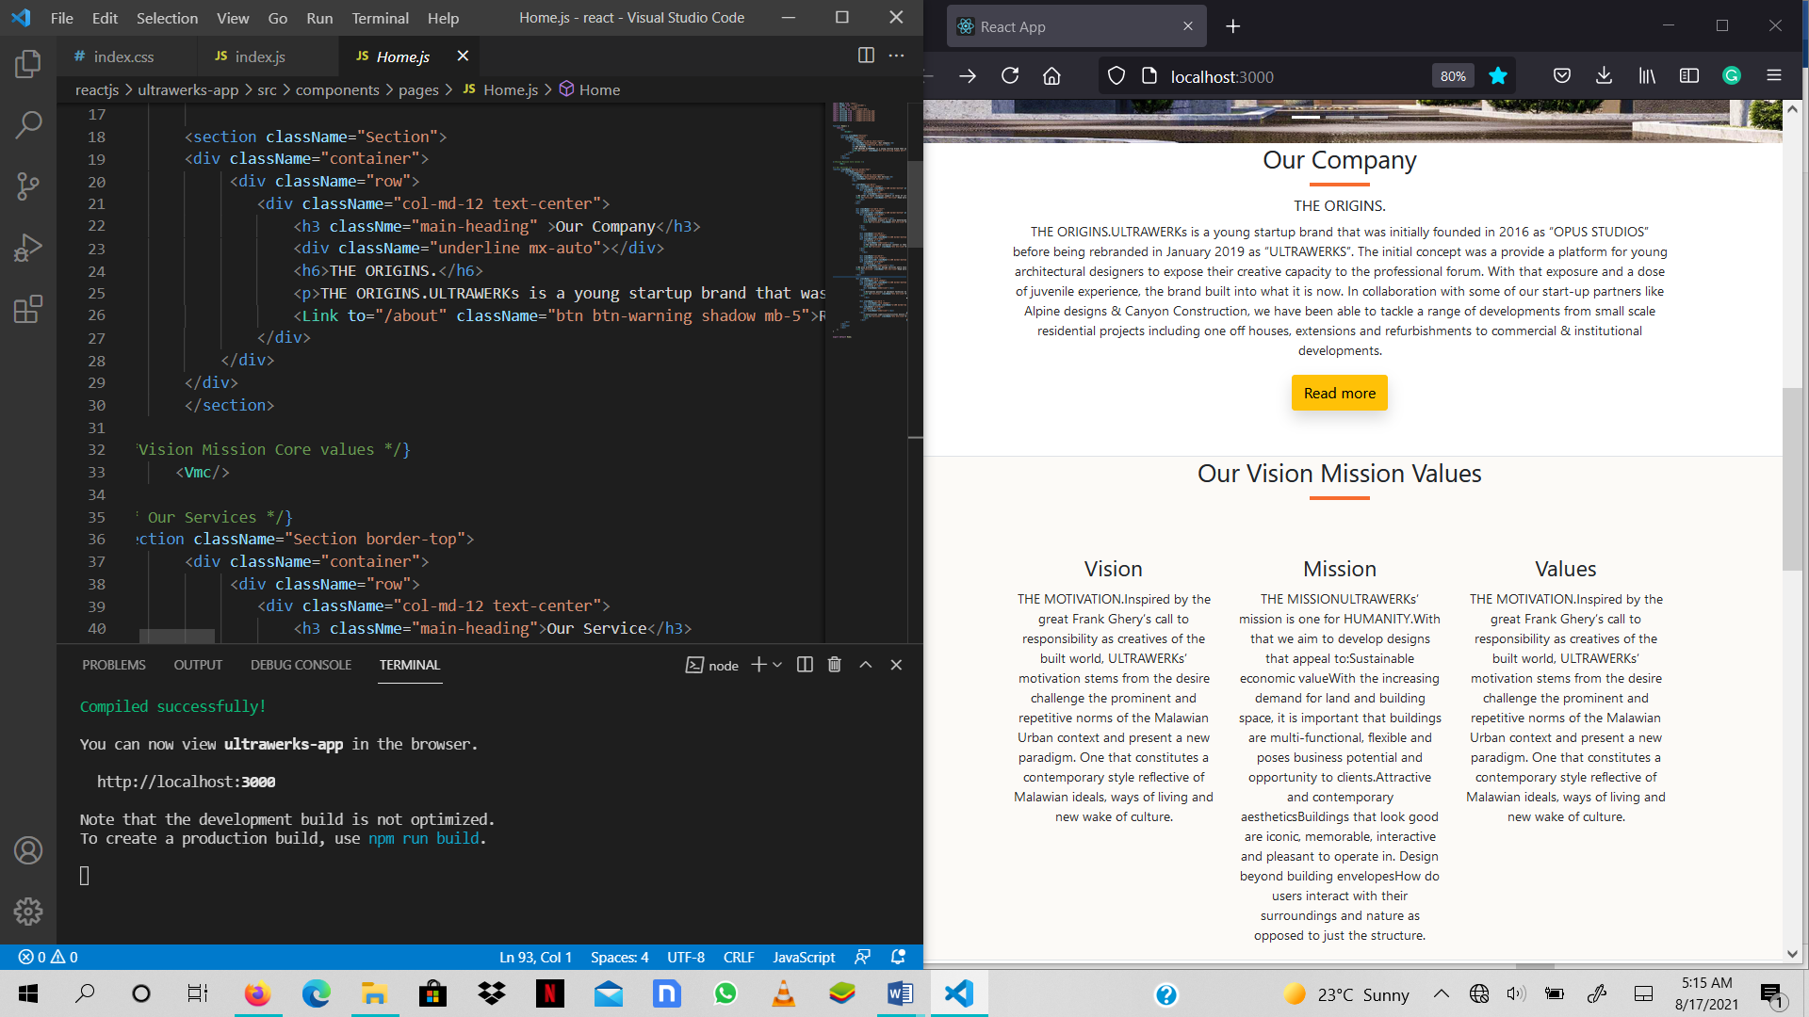

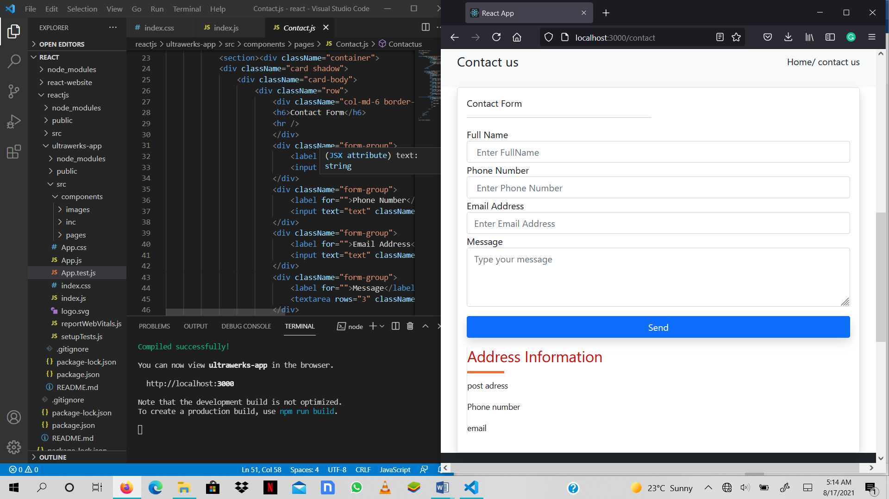

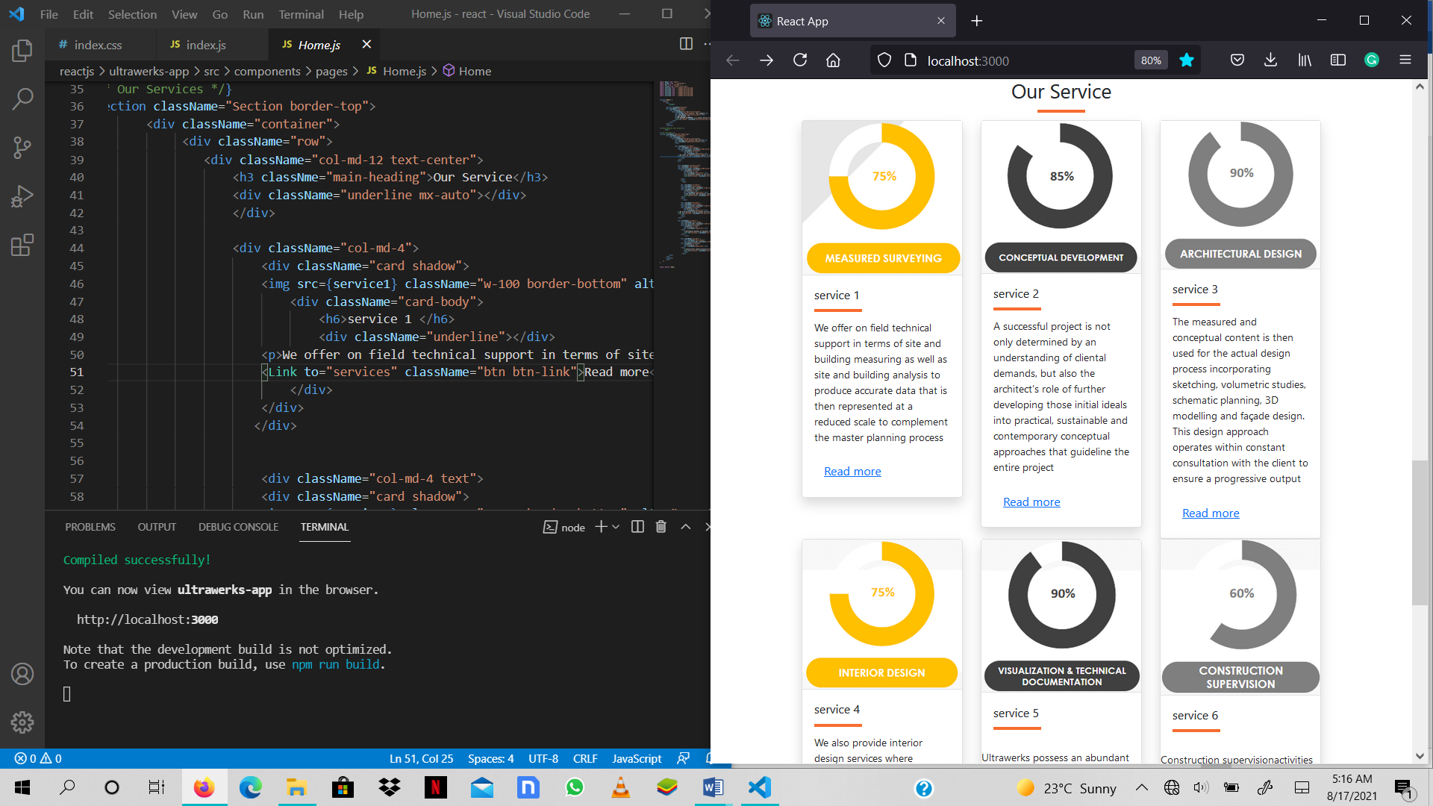

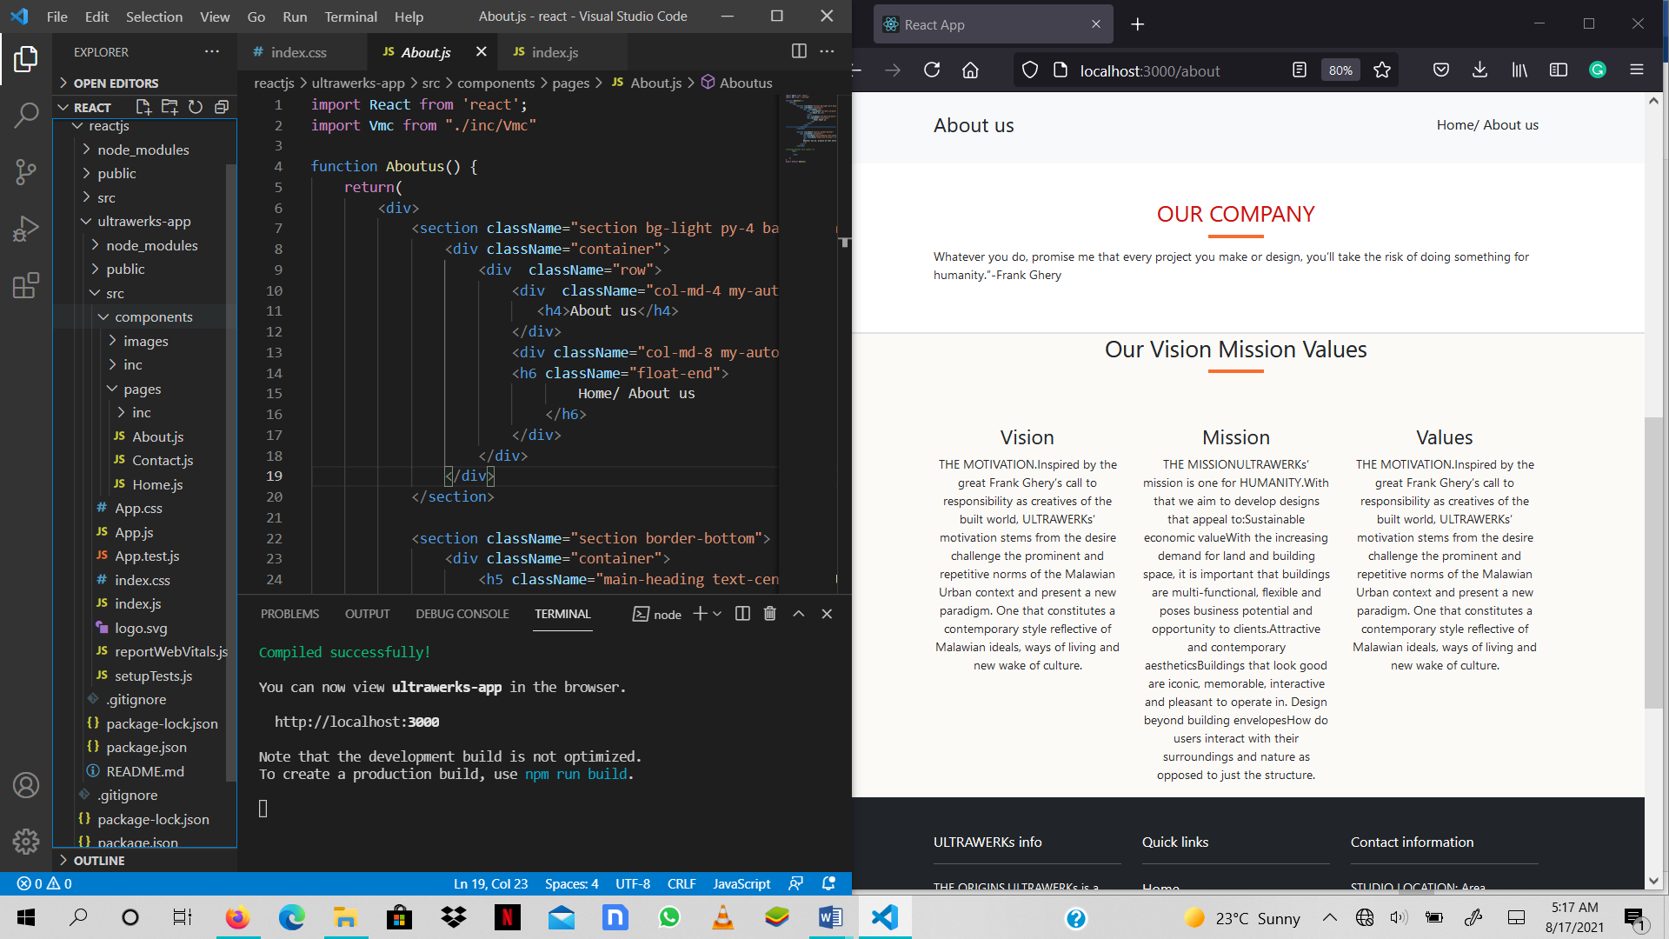

<details in appendices>

***Implementation***

Construction <the programming phase>

Development/build approach (use of use of some software development tools/platforms; i.e. Integrated Environment Development (IDE), or traditional coding approach – thru some specific programming language, …etc)

* Code <language> – C++, HTML, CSS, PHP, Python, Java, …etc
* and algorithms

<details in appendices>

Testing

* should incorporate/touch on the general software test perspectives/categories

Test Plan

* test cases/test scenarios
* test data
* test results

Installation

Architecture

* DBMS deployed
* system requirements
* installation data

5.5 Summary

# References

1. Moturi, E. N. (2014). *VIRTUAL TOUR TOOLFOR ENHANCING DESTINATION MARKETING.* Nairobi: UNIVERSITY OF NAIROBI SCHOOL OF COMPUTING AND INFORMATICS.

2. Amresh, A., & Okita, A. (2010). *Unreal Game Development.* Natick: A K Peters, Ltd.

3. Arpak, A. (2008, June 24).

4 Bakri, H., Allison, C., Miller, A. H., & Oliver, I. (2016). *Virtual Worlds and the 3D Web – Time for Convergence?* United Kingdom: School of Computer Science, University of St Andrews,.

5. Burger, N. (2013). *Realtime Interactive Architectural Visualization using Unreal Engine 3.5.* LUDWIG-MAXIMILIANS-UNIVERSITÄT MÜNCHEN.

6.Challenges for marketing communications in the digital age. (2017). *Researchgate*, 185-193.

7.Cummins architecture & designs. (2021, March 21). *What is architectural design.* Retrieved from Cummins architecture & designs: http://www.cumminshomedesign.com

8.Dennis, A., Wixom, B. H., & Roth, R. M. (2009). *SYSTEM ANALYSIS AND DESIGN.* Danvers: John Wiley & Sons,Inc.

9.Grudzewski, F., Awdziej, M., Mazurek, G., & Piotrowska, K. (2018, March 4). Virtual reality in marketing communication – the impact on the message, technology and offer perception –empirical study1. *Economics and Business Review*, pp. 36-50.

10.Hajduk, G. (2017). Challenges for Marketing Communications in the digital age. *Research gate*, 186-193.

11. Indraprastha, A., & Shinozaki, M. (2009). The Investigation on Using Unity3D Game Engine in Urban Design Study. *ITB J. ICT, III*(No. 1), 1-18.

11. Janetius, S. T. (2020). What is architecture. In P. J. S.T, *Architectural psychology* (pp. 7-12). Mishil & Js publishers.

15. Laboratory of Computer Science for Complex Systems, France2Dialonics, Lannion, France. (2011). GetInvolvedinanInteractiveVirtualTourofBrest Harbour: Follow the Guide and Participate. *Springer-Verlag Berlin HEidelberg*, 93-99.

16.Meiling, Y. M. (2015). VIRTUAL INTERACTIVE INTERIOR WALKTHROUGH USING UNITY3D. 1-7.

17. Onyesolu, M. O., & Eze, F. U. (2011). *Understanding Virtual Reality Technology: Advances and Applications.* Inno State: Federal University Of Technology.

18. S.Gallagher, R. (2012). *Computer visualization-Graphics Techniques for Engineering and scientific Analysis.* Solomon press.

19.Schroeder, S. A. (2011). *Adopting Game Technology for Architectural Visualization.* Department of Computer Graphics Technology Degree Theses.Paper 6.

20.Valacich, J. S., George, J. F., & Hoffer, J. A. (2012). *Essentials of Systems Analysis and Design.* New Jersey: Pearson Education.

21.Van, K., Brengman, M., & Willems, K. (2017a). Experimental study on empact of a virtual reality experience in a shopping mall. *Escaping the crowd*, 177-191.

22.Yan, J. (2014). *An Evaluation of Current Applications of 3D Visualization Software in Landscape Architecture Software in Landscape Architecture 8.* Utah State University.